Transfer Process

Possible scénarios :
- Change of lessee
- Equipment changes
- Payment schedule changes

Required Documents:
- Appendix according to the file type (A, G or assignment agreement)
- PAD agreement (By client B-assignee)
- E-Sign summary if documents were signed electronically via the One Span platform
- ID (client A & B)
- Insurance documents (if not covered by GAI)
- Void cheque Client B
- Credit decision with the IFL # of the new contract (with client B)
- 1st page of the original contract (for reference)
- IPC
- REQ/Corp profile (In Vision’s new app)- annual filings to be up to date for client B

Step-by-Step Procedure

Sales
- Provide the buyout
- Create the documentation and POA using the automated tool
- Send the request to Sales Support
- Handle the delivery of the Welcome Package to the client, including the POA

Sales support
Refer to the manual on SharePoint for details
- Create the assumption in IFL
- Ensure the payment grid in IFL matches the documentation
- Provide the IFL number (new contract) for the package
- Validate the documents • Manage communication with Sales
- Ensure that the payment grid in IFL matches the documentation
- Send us the request by email

Validation
- A templated email is received from Sales Support in the CoreValidation inbox
- The package is available in the V2 folder
- Validate the documents and follow up with Sales Support if corrections are needed
  - Ensure that the payment grid in IFL matches the documentation
- Once validation is complete, sign and date the document
- Make the amendment in PPSA
- Create a Welcome Package including:
  - All documents signed by the client (Annex, IPC)
- Send the Welcome Package to the AM , The insurance team has been looped in (assurance@mhccna.com) for visibility on the coverage details.-EXCEPT if covered by GAI
- Save the complete package in Vision (original file application)

See example here:
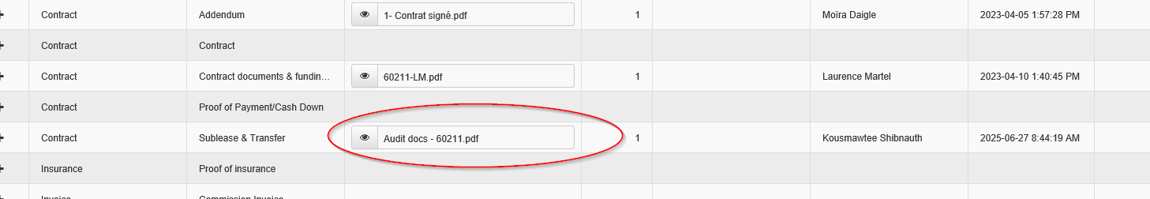

Validation in Infolease
If the Client A is paying the transfer fee
- Validate the charge (if the fees have been integrated)
- Contrat Section
- Enter contract number of client B (the new one)
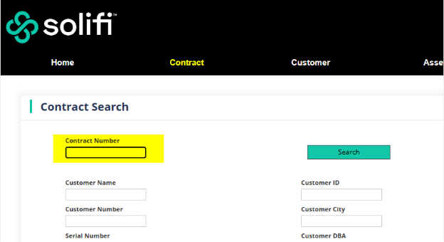

Select «charges»
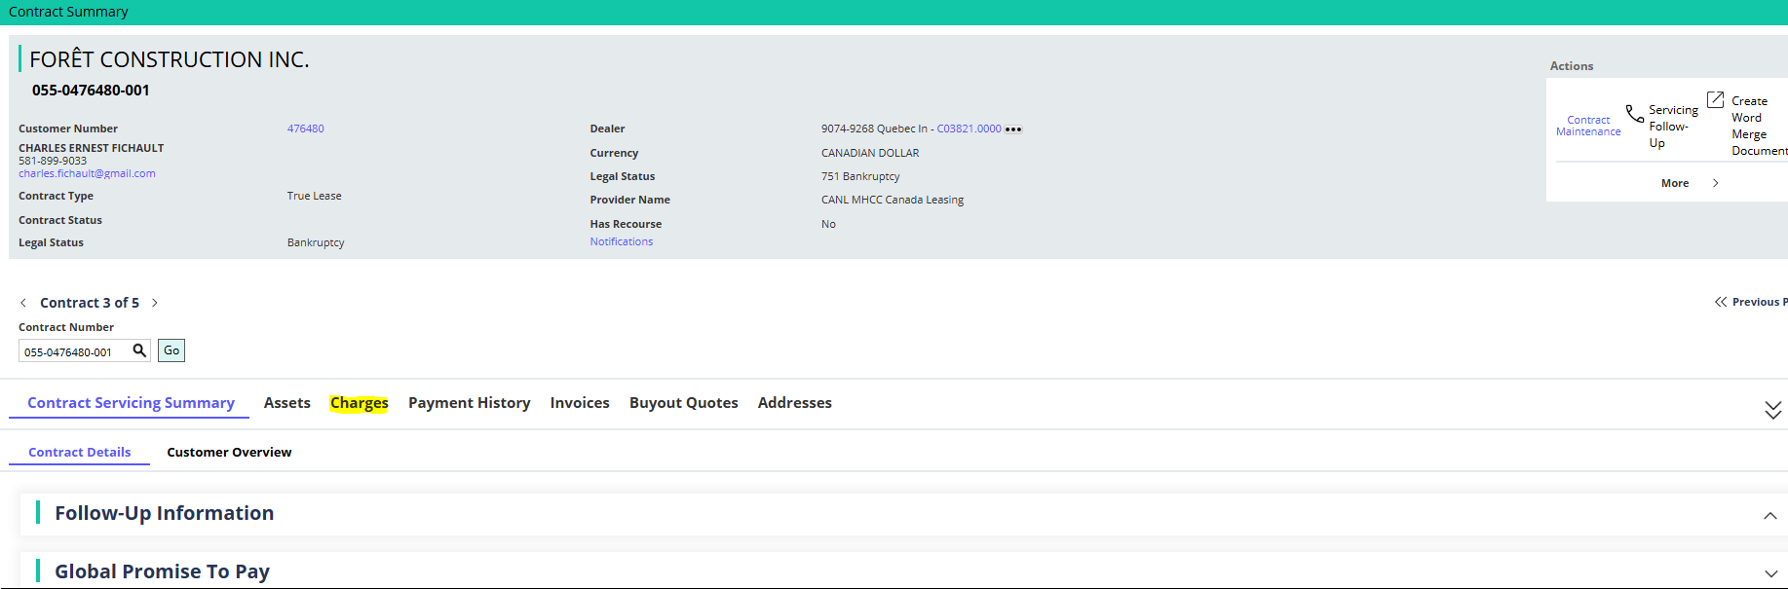

Validate the type of fee and the amount
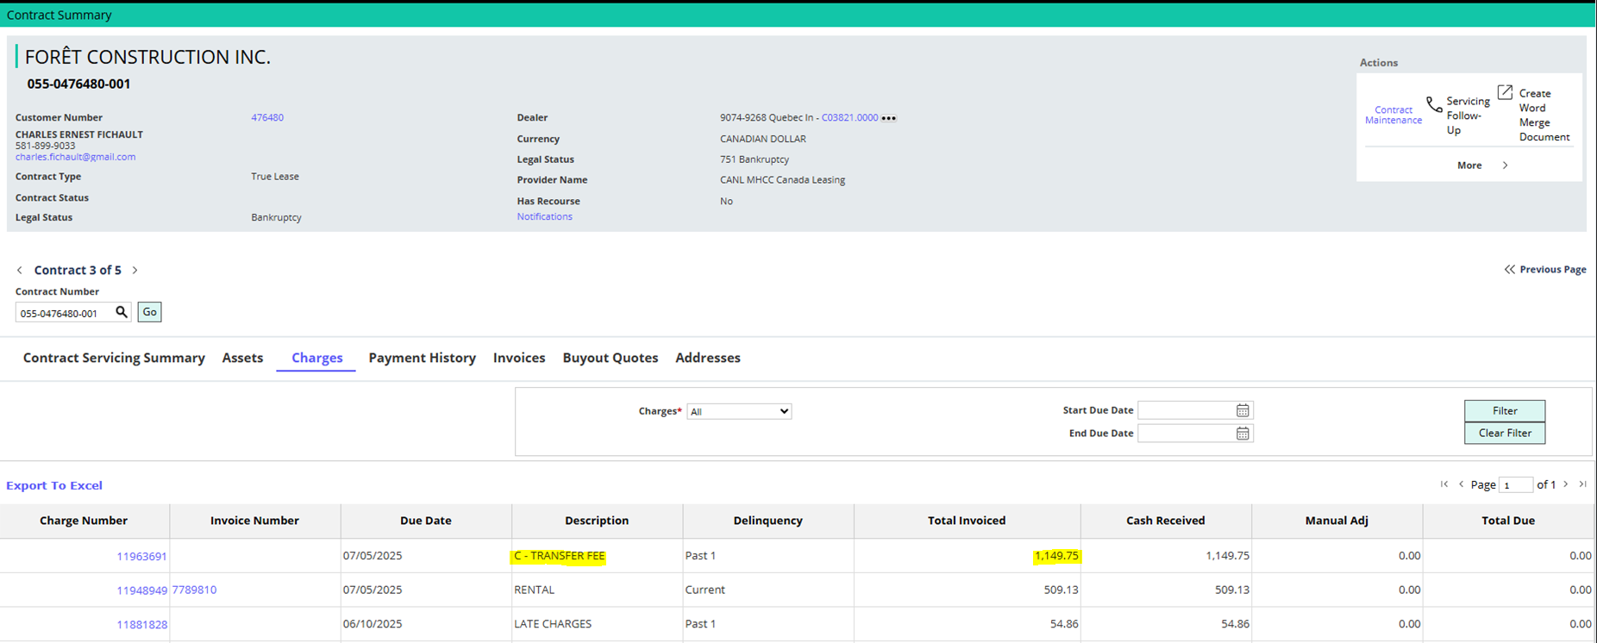

Validate the PG and CG
- Select contract maintenance (upper right)
- Select contract information-third parties
- In the section related party code, you’ll see the name of the guarantor
  - Cle contact guarantor for the PG
  - Cle corporate guarantor for the CG
